In- lab exercise

* create a keyspace called “superflexApartments” that contains 3 tables:
  1. first table(column family) is “tenants”
  2. second table is “units”
  3. third table is complaints

model this database by creating at least 4 columns for each table and populate those tables with at least 2 rows for each table

apply the following requirements when modeling your table:

* in tenants table each row must correspond to one tenant only and each tenant can have **multiple cars** which must be registered in the system. Create a column called tenant_cars **to include the set of the cars each tenant own.**
* In units table, each row is for only one unit and each unit can have more than one room. Each room have different measurements. **Create a column called rooms which will record each room and its size using the collection data type.**

Submit the screenshots of the following queries :

1. Describe keyspaces;



1. Describe tables;



1. Select * from tenants;

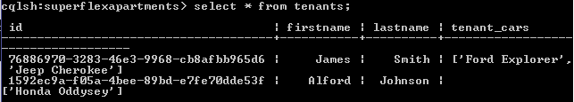

1. Select * from units;

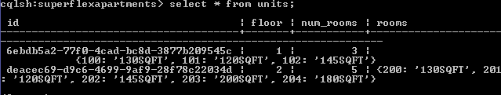

1. Select * from complaints;

